**ARYAMAN MISHRA**

**19BCE1027**

**Drive Link:** **https://drive.google.com/drive/folders/10abxunpu08QHtXNJNo_4haiAAFIzsMr6?usp=sharing**

Use a audio processing software and perform the audio editing tasks–

Import audio

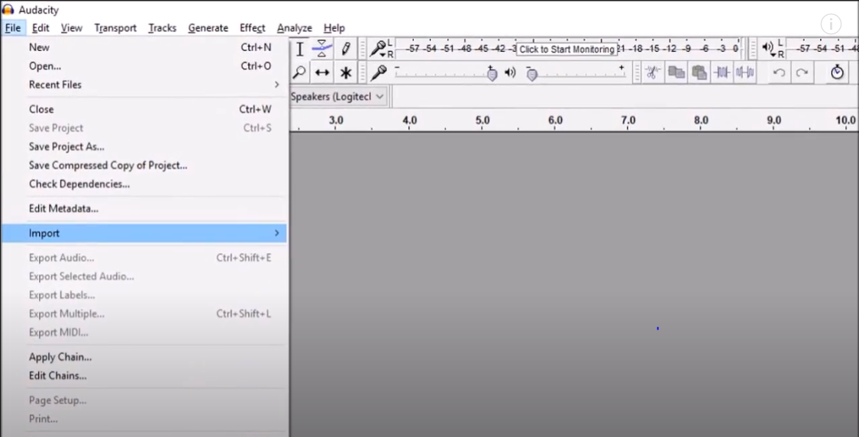

Select and edit the sound

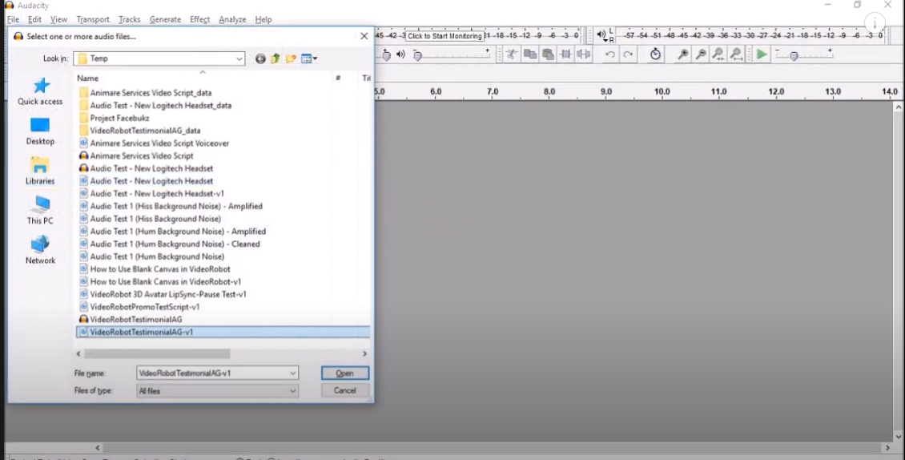

Create fade-in fade-out effects

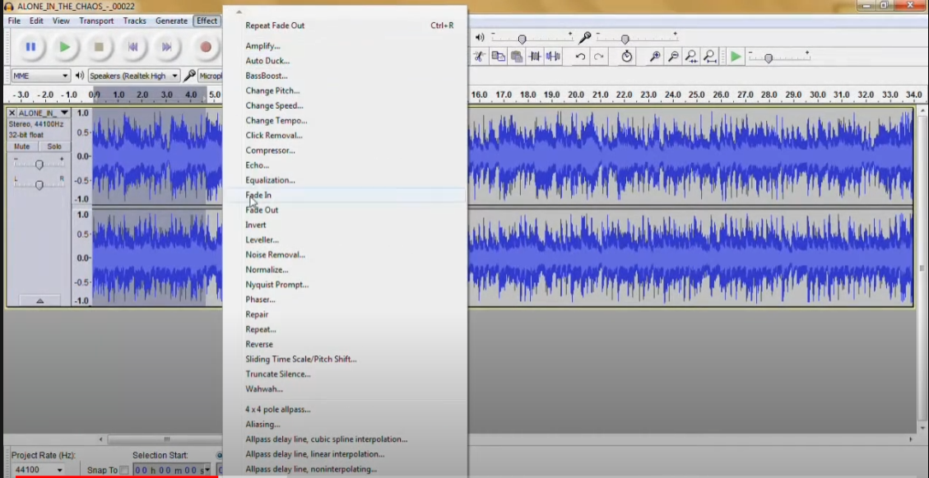

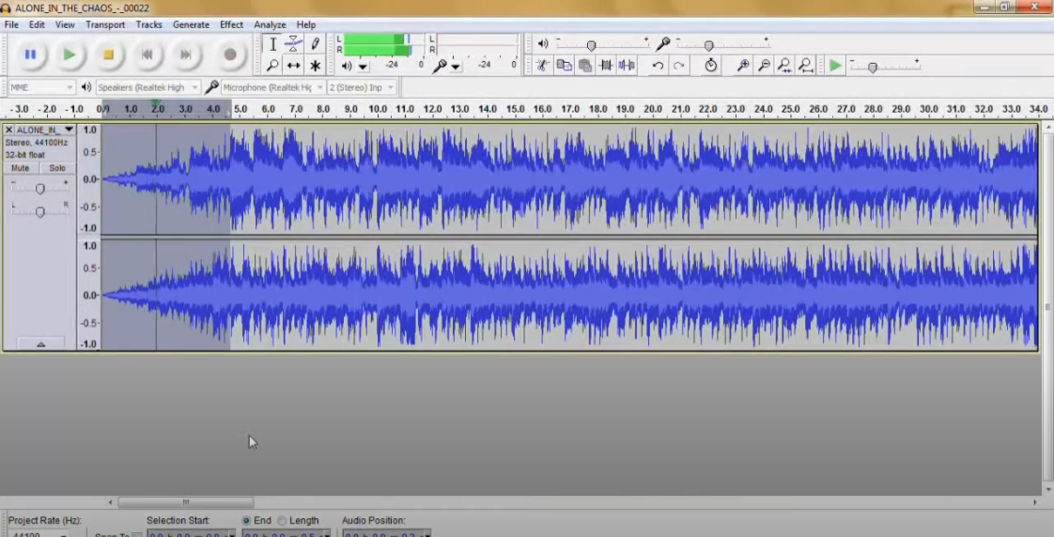

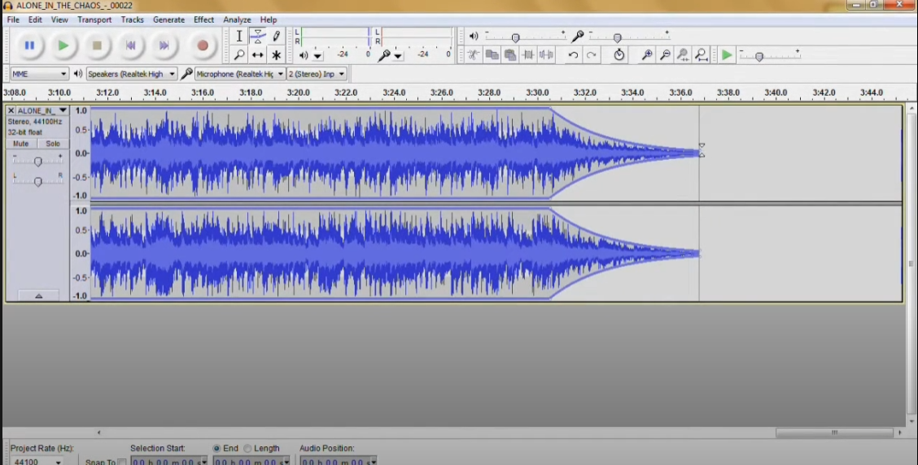

, Label audio segments,

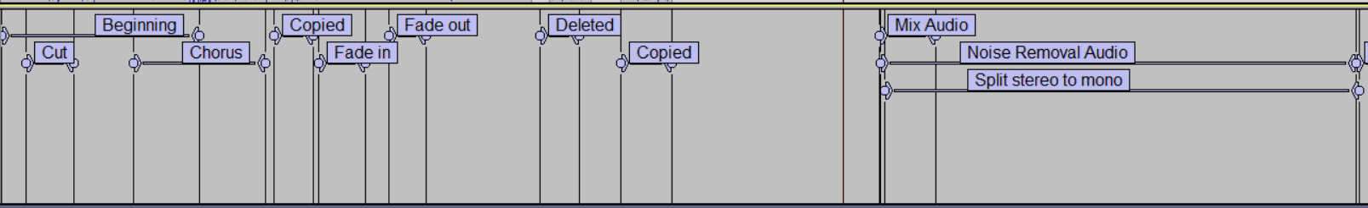

Use noise remove filter

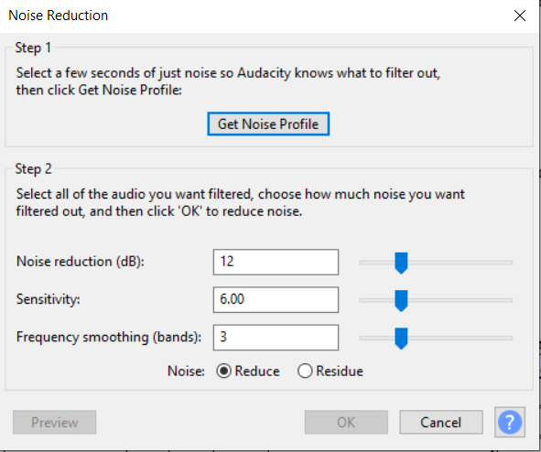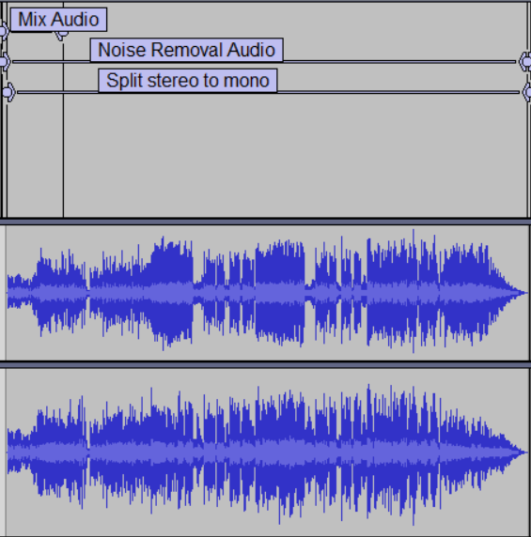

, Mix audio

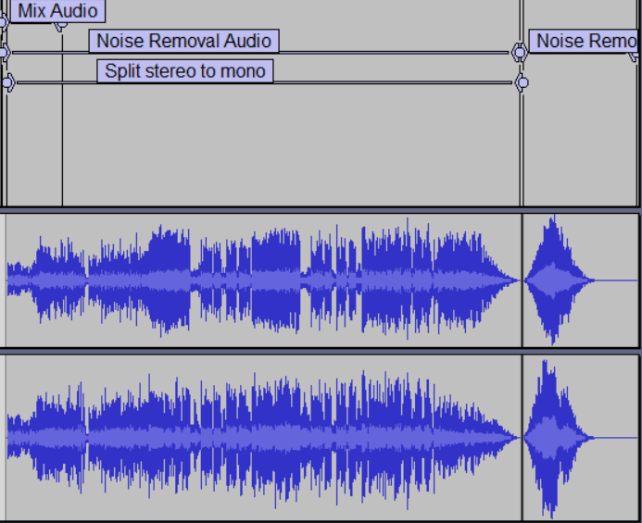

, Change stereo to mono tracks,

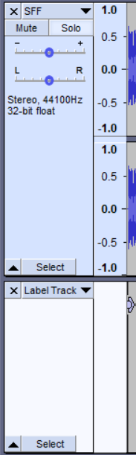

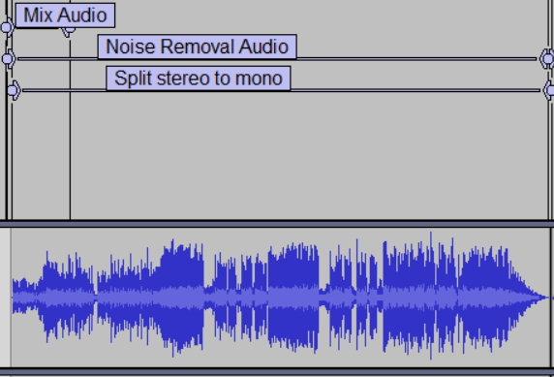

Export audio to different format and save.



